Minisceongo Yacht Club
Women's Regatta
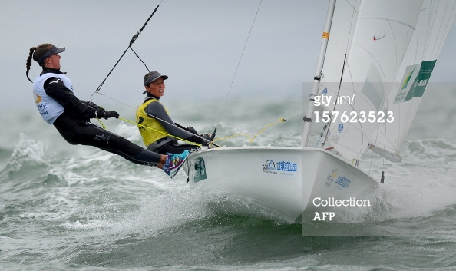

Saturday 15 June 2013

Race Instructions and
General Information
To: All Sailors

From: MYC Race Committee

Welcome to the 2013 Women's Regatta. On behalf of all our members, we welcome you to our club and wish you fair winds and smooth sailing during the regatta.

Race Committee
Jessie Fitzgerald
St John Forbes
Bob Tamagny
Dennis Doyle
Kevin Silver

GENERAL INFORMATION:

Saturday:

Buffet Breakfast 0800 – 1000 hours
Skippers Meeting 0930
After Race: Soda, Beer, Snacks, BBQ 1600 hours

OVERNIGHT: Any available space at MYC on Fri. and Sat. night at no charge. Special rate is available for week before and/or after. Please contact Dennis Doyle (201-820-7204) or Tony Schweiker (201-755-1772).

TIDES AND CURRENT: Information on the predicted times of high and low tide.

Saturday

Tides: Low High

10:25 16:14

Max. Ebb 09:50
Slack 13:49
Max. Flood 15:46

RACE INSTRUCTIONS

INSTRUCTIONS: HRYRA 2013 COMMON SAILING INSTRUCTIONS except as modified below.

ELIGIBILTY: All entries must be registered by 1030 hours EDT Saturday, June 15, 2013 Participants attempting to register after this time will be scored at the discretion of the race committee.
All entries must check in with the race committee prior to the first race.

MANAGEMENT: The Regatta Committee of the Minisceongo Yacht Club shall manage the races.

NOTICES: Notices and changes will be posted on the front windows of the Minisceongo clubhouse. The Race Committee may announce such changes 30 minutes prior to the first warning signal.

CHANGES: Changes to these sailing instructions will be posted at least one hour prior to the first warning signal on the day it will take effect except that any change in the schedule of races will be posted before 1900 hours the day before the regatta.

SCHEDULE of Races: Saturday, June 15: First warning signal at 1100; Three (3) races scheduled.

The second race and subsequent races will be started as soon as practical after the completion of the first race.

DIVISIONS: Modified from the HRYRA 2013 COMMON SAILING INSTRUCTIONS.
Division 1: All Women Spinnaker
Division 2: All Women Non-spinnaker
Division 3: Woman Skipper Spinnaker
Division 4: Woman Skipper Non-spinnaker

RACING AREA: The racing area will be as shown on the chart supplied.

COURSES: Course descriptions are listed on the attached sheet of Race Courses. A course will be designated and displayed by the race committee no later than the warning signal for that race. If a windward/leeward course is chosen it would be announced on channel 72

RADIO COMMUNICATION: As described in the HRYRA 2013 COMMON SAILING INSTRUCTIONS.

STARTING AREA: The starting area will be at buoy, H. Please refer to the course sheet to determine the starting area for each wind direction.

THE START: The Warning will be initiated five minutes prior to the division start by displaying the division flag and one sound signal. The Warning Flag for the next division may be raised simultaneous with the start of the prior division. The visual signals are described below.
The flag for Division “1” will be Signal Flag "1". This amends HRYRA 2013 Common Sailing Instructions.

1st Division Flag
WHT Pennant Red Dot 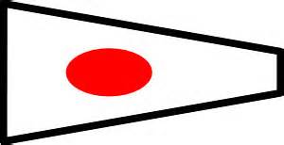

2nd Division Flag
BL Pennant WHT Dot 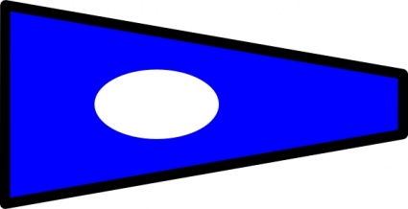

3rd Division Flag
Red/WHT/ BL Pennant 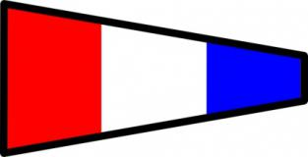

4th Division Flag
Red Pennant WHT Cross 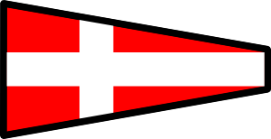

SEQUENCE:
Sound
Min. Signal Flag (s)
5:00 one Class Flag up Warning
4:00 one P up Prep
1:00 one P down One minute
0:00/5:00 one Red down, Blue up Start Warning


P Flag
(BL/WHT SQUARE)

The starting line will be between an RC flag on the committee boat and the starting mark.

An anti-barging mark may be attached to the committee boat and should be considered an extension of the committee boat for purpose of rule 31 (touching a mark).


POSTPONEMENT: Signaled by hoisting the AP flag (red and white vertical bars) and making two sound signals. Upon lowering the AP there will be a sound signal. If racing is to resume, the warning signal for any division not yet started will be made one minute after the pennant is lowered.

INDIVIDUAL RECALL: Signaled with one sound signal and an attempt to notify on VHF channel 72 each boat recalled by the sail number. However, it is the responsibility of each boat to make a proper start. The “X” flag may, but need not, be shown.


GENERAL RECALL: Signaled by hoisting the code flag “First Substitute” (triangular pennant, yellow field with a dark blue border) and making two sound signals after the start signal.


SHORTENING COURSE: Signaled by two sounds and code flag “S” may be displayed. The finish line will be between a flag on the committee boat (or auxiliary boat) and a mark of the course.
The race committee will attempt to notify the fleet on VHF channel 72.

TIME LIMIT: As described in the HRYRA 2013 COMMON SAILING INSTRUCTIONS.

THE FINISH: The Finish line will be between an RC flag on the committee boat and the finishing mark

PENALTIES: As described in the HRYRA 2013 COMMON SAILING INSTRUCTIONS.

Protest forms shall be submitted to the Race Committee within 30 minutes of the Race Committee boat docking.

SCORING: As described in the HRYRA 2013 COMMON SAILING INSTRUCTIONS.

RESPONSIBILITY FOR SAFETY: As a condition of the participation of any boat in any race or related activity sponsored or undertaken by Minisceongo Yacht Club, the owner, helmsman and each crew member agree that the safety of the boat and her crew and decision whether or not to start or continue to race is solely their responsibility, and each of them waives all claims which he or she or any heir, representative, successor, assignee, may have against Minisceongo Yacht Club and its officers, trustees, members, or committees arising out of or in any way connected with participation in such race or activity.

MYC WOMEN'S REGATTA 2013 COURSE SHEET

Marks to be used are as follows: Government buoys 18, 22, 24, and 26; Club Marks “B”, "C", “D”, “F”, “G”, "H", and "K" (Orange cans). Inflatable marks may be substituted in the event the “can” buoys are missing or damaged.
DIVISIONS | COURSE
1 | D
3 | E

The courses will be designated as shown. The First column designates the divisions; the second Column designates the course. If there are no division letters, all will sail the same course. If “1” and “3” are shown, divisions “1” & ”2” will sail the same course and divisions “3” & “4” will sail the same course. If “1” & “4” are shown, divisions 1, 2, & 3 will sail the same course and division “4” will sail a different course.

Approximate position of Race Buoys

Buoy | Latitude |  |  | Longitude
 | Degrees (N) | Minutes | Seconds | Degrees (W) | Minutes | Seconds
Y | 41 | 14 | 23.2 | 73 | 57 | 25.8
B | 41 | 14 | 12.3 | 73 | 58 | 05.5
C | 41 | 13 | 54.4 | 73 | 56 | 33.5
D | 41 | 13 | 28.0 | 73 | 55 | 51.1
26 | 41 | 13 | 18.5 | 73 | 57 | 07.4
F | 41 | 12 | 39.2 | 73 | 57 | 34.2
H | 41 | 12 | 54.5 | 73 | 56 | 13.3
G | 41 | 12 | 20.4 | 73 | 54 | 19.1
24 | 41 | 12 | 11.8 | 73 | 56 | 39.0
K | 41 | 11 | 30.8 | 73 | 55 | 08.1
22 | 41 | 11 | 03.8 | 73 | 55 | 59.5
Datum: WGS84 Checked April 2013
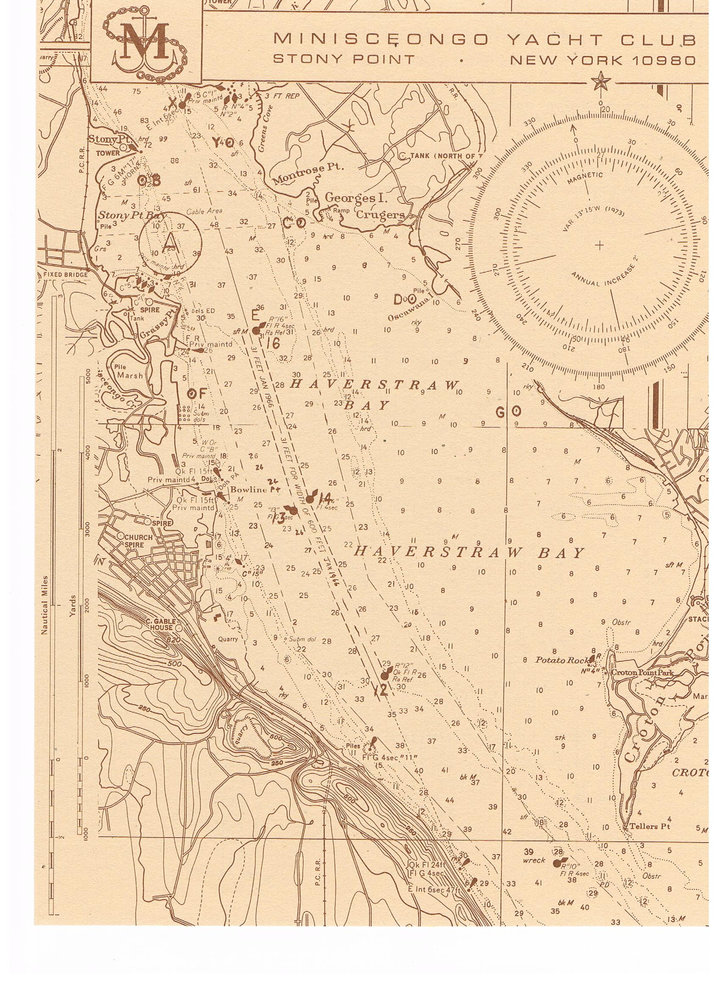
K
B
26

24
22
D
G
H
F
C

